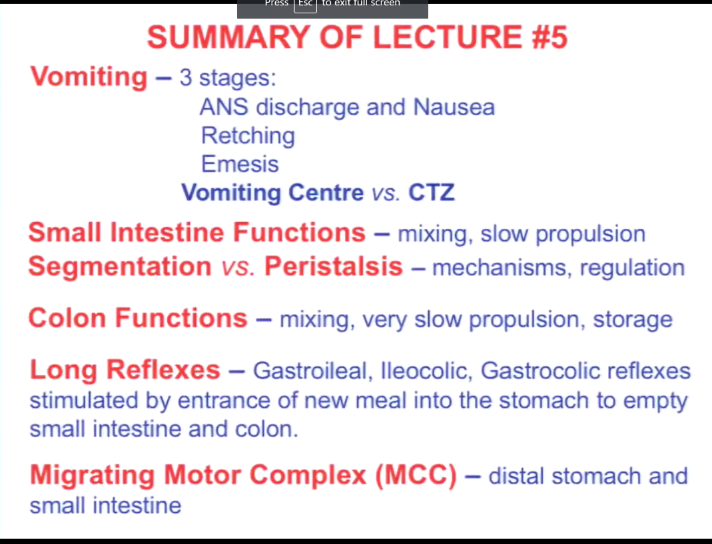
Vomiting – 3 specific stage
- Nausua + widspread AUS
- Retching – uncoordinated muscular contraction of the diaphram that didn’t produce expotion from the mouth
- Emesis is the final , due to the large gradient of pressure built up in abdominal cavity because of the contraction of the abdominal muscle and the diagpharm pushing down. (High pressure in stomach which forces the content out) No reverse peristalsis is the GIT, the GIT is passive
- Organize by the volmiting center at the medulla level
- In additino to volmiting center, there is another center call : CTZ which is on the 4th ventricle and outside the blood brain barrier that is responsible for detecting emititng agent like toxic and when activated sent the signal to volmting center which activate the efferent
Small intestine : where most of the digestion and absorption take place
- Mixing, we can absorb and break down
- Slow propulsion to have enough time in small intestine
- Main type of muscula contraction is segmentation, but there is small amount of peristalsis.
- BER in small intestine and colon (very irregular) as well
Colon: the job is to reabsorb water and minerus, all the nutrients happen at the level of small intestine.
- The colon, the function is to reabsorb the liquid
- The content of the colon, 1.5L in 200Ml out as feces
Long Reflexes : no need to remember the name of the long reflexes but the key idea is that this is what stimulus the movement from one compartment to the next. The movement is from small intestine to the colon, colon to rectum (the end of meal.) We want to make room for the next meal
MCC: Can only pass very small thing to GIT with the pyloric sphicter being so small, but we have Migrating motor complex that will sweep any remaining componenet out of GIT at distal stomach and the small intestine to serve as house keeping function to clean out what have left, or havent been absorb .

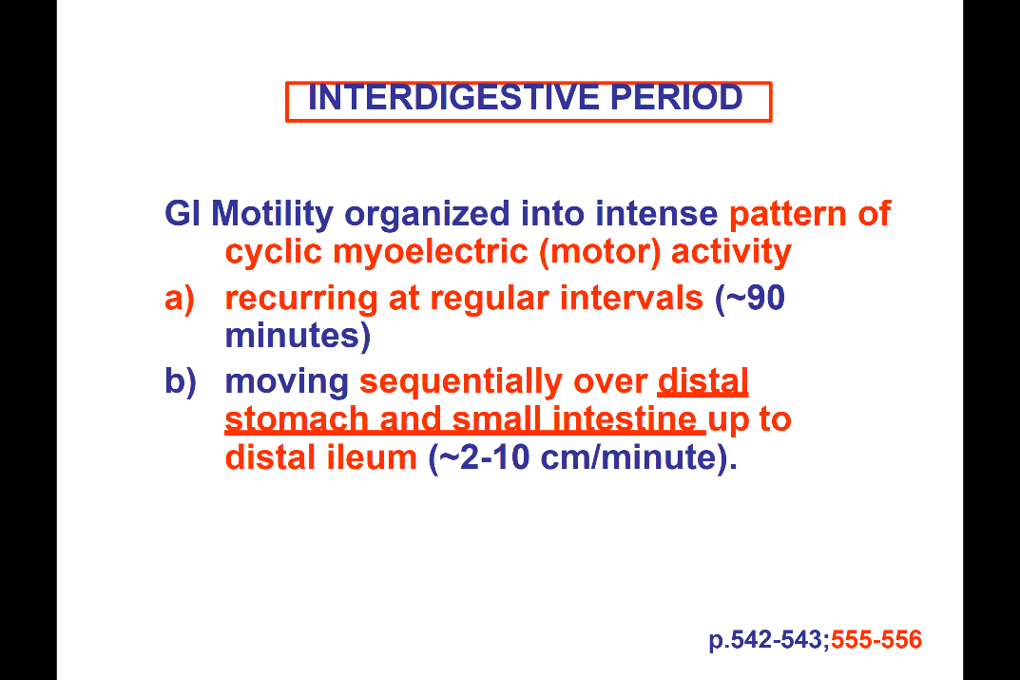
In between meals, absence of meals (interdigestive period): the activity of motor system in GIT that is organized in an intense patter = called “cyclic myoelectric activity “
- Because it is very rhythmic, every 90 min in the absence of meal
- Move sequentially over the distal stomach and SI
- This is not peristalsis!!! it is happening sequentially but not a smooth propagation
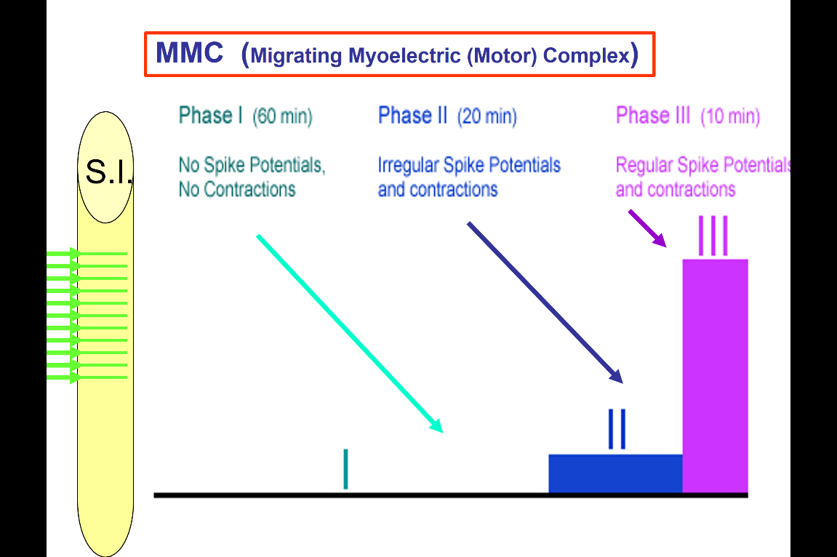
- also very slow , section by section (but not a propagated wave )
Mmc – look at the section of small intestine, at the level of musculature between the meal
Phase 1
- at first 60 min, nothing happen no spikes no contractions
Phase2: some irregular spikes potential , small contraction
Phase3:
- 10 mins, start to excite
- Regular spike potential and large contractions
that’s the migrating motor complex, call this because it will happen in one segment of SI, and next and next as we move down the GIT, 2~10 cm per min of moving

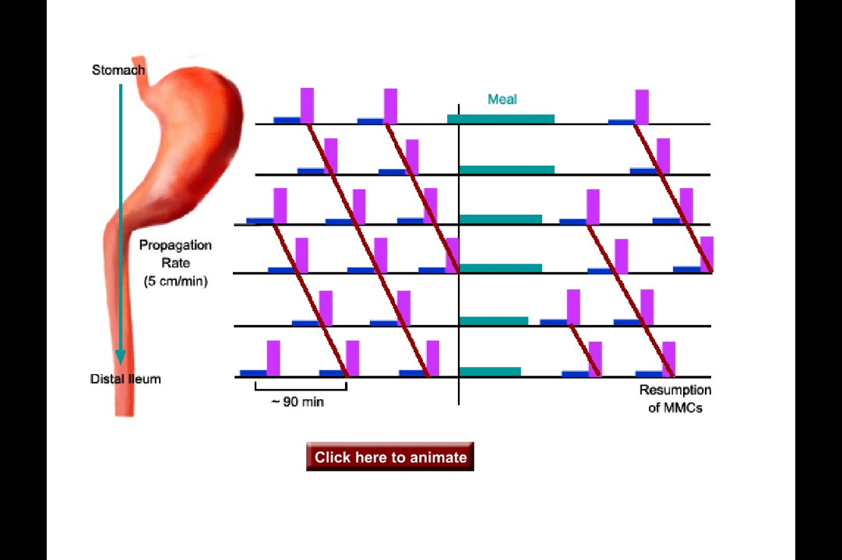
Remember this is only happen in distal stomach and the entire SI
- If start at the begging, see little activity ramping up. In absence of meal there is rhythmical activity
- Once meal come, disrupted
- After the meal start again
We call this migrating, because it migrate through the GIT, so that this will happen through out the length of GIT.

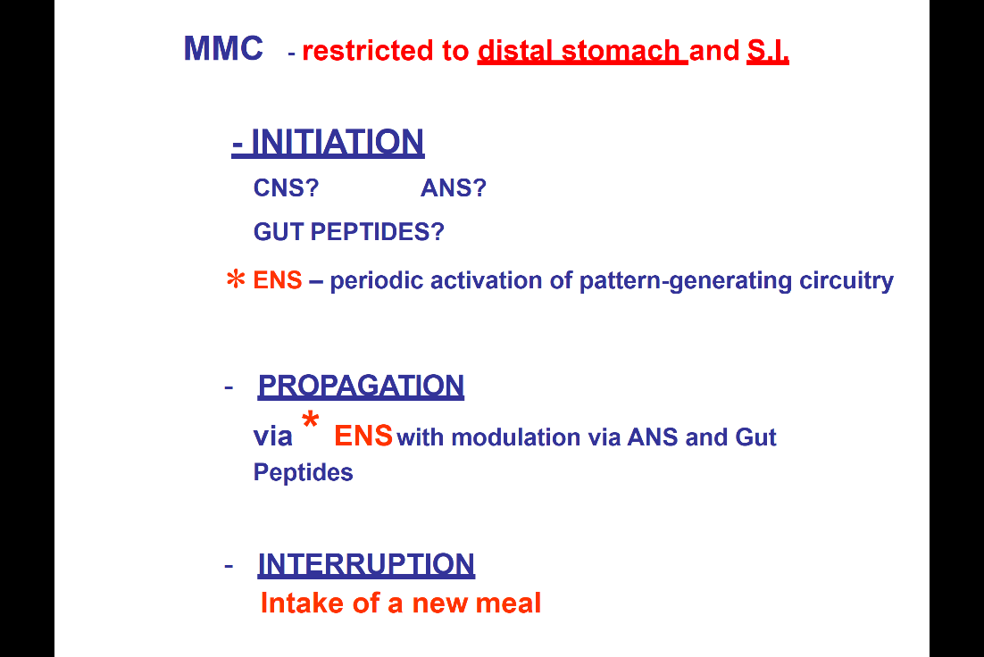

We don’t really know what cause this to start, this rhythmical activity constantly occur in the absence of meal. But we know, when cut CNS input to GIT, MMC still happen. We know that
- Can be modulate by gut peptide, autonomic nervous system
- the ENS is essential, within the ENS, there is a periodic activation of pattern generating circuitry
- we don’t know the start, but its propagate through the ENS and be modulate by the ENS and the Gut peptides
- every 90min, activation of ENS that produce the contraction
- the interruption is the intake of new meal: in absence of meal the 90min MMC will happen.
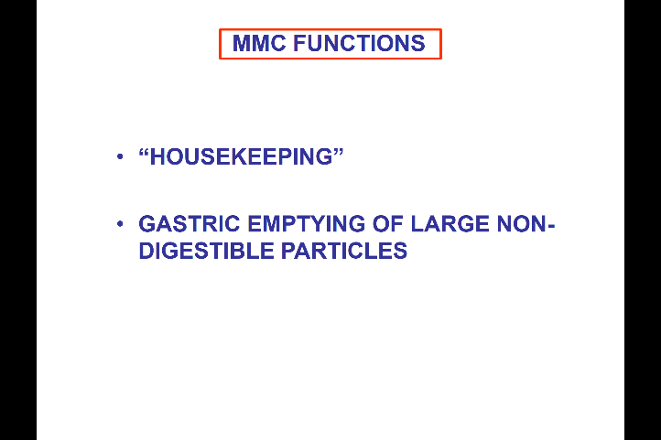
The function of MMC is to serve as House keeping to keep the GIT clean.
- In the absence of meal, there is constant secretion within the Git. This kind of fluid/secretion wouldn’t be enough of stimulus to cause contraction or peristaltic wave. That’s when MMC can move the fluid through the system in the absence of meal.
- Similarly, the GIT is constantly turning over cells, need to remove the dead cells.
- The body will also reabsorb the liquid from the secretion, break down the cells , and takeback the nutrients that we can. Can absorb that, move to the GIT.
The gastric emptying of large non-digestible particles, this is when swallowing a penny
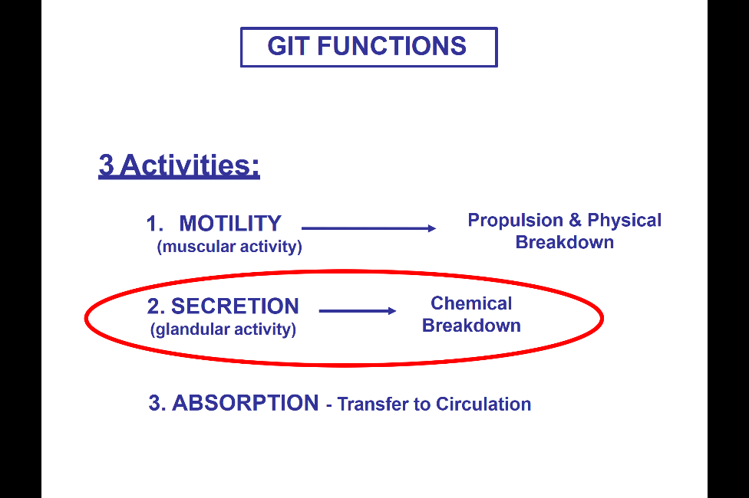
- When during the digestive period, the peristaltic wave move to stomach, the sphincter is open. As have the strong wave move to the stomach, the sphincter is closed as the wave is moving forward
- In the absence of mean and the present of MMC, the sphincter is remain open. There will be strong contraction but not the same way as antral systole. This allow us to push things through the lumen even if it’s a large size. This happen during MMC
- Happen in the stomach and SI, push everything through

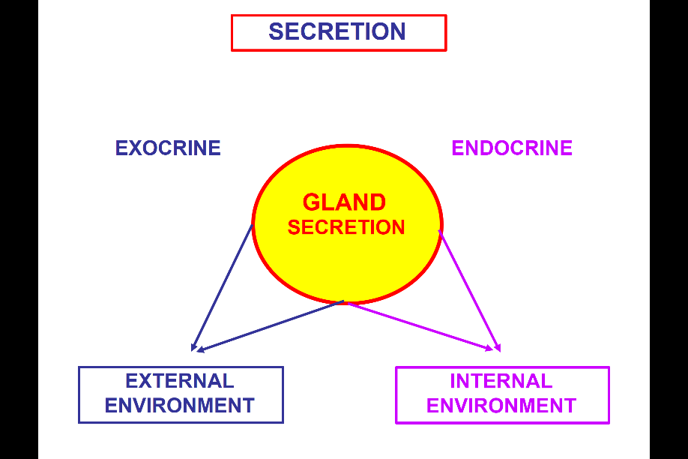

Secretion. Modulate by glandular activity associate with GIT for chemical breakdown of food

Secretion depends on glands can either be GIT itself (intersperses) and the GIT wall (diffuse endocrine system) also have external gland secret content to GIT.
- Once the secretion take place, can be either exocrine. Secret in to the gut, joining the external environment because the GIT is in contact with external world (ex; saliva) but the key is the secretion is within the Git, which is in contrast with the endocrine
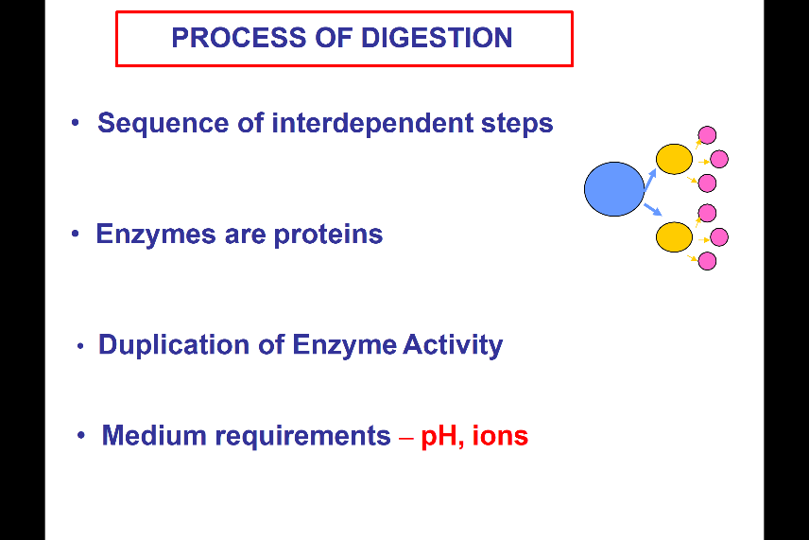
- Endocrine : release the content to the blood stream (internal environment ) because blood stream is the internal environment of the body

The process of digestion relies on a sequence of interdependent steps. When have food molecule need to
Break down the large molecule -------- small ---- absorbable
- need one step to happen before the next step
- once the enzyme have been use to break down the nutritional component, they will be recycle. (recover the amino acid, to be reuse in the body)
- same enzyme may be release in the different part of GIT
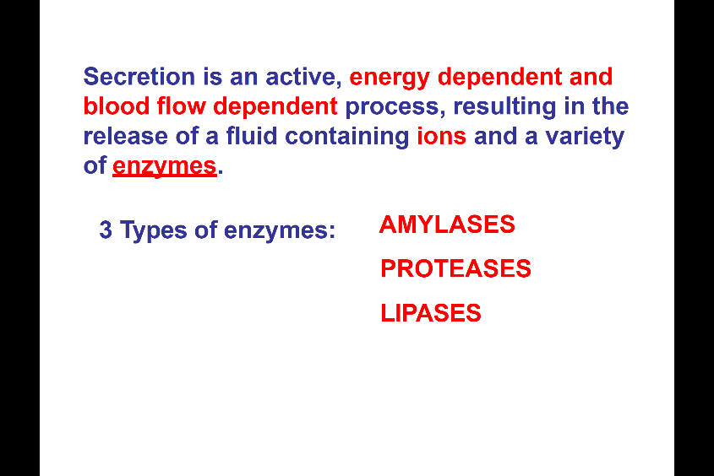
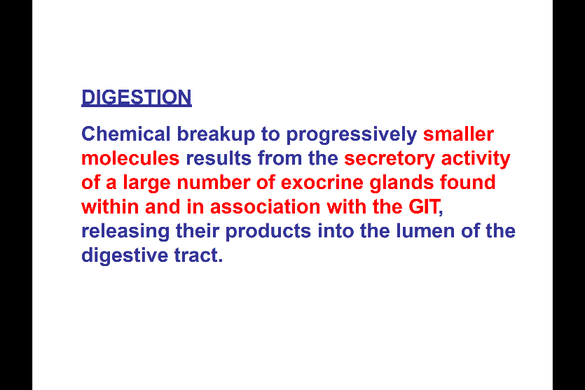
- different enzyme have different medium requirement: depend on the PH, ionic requirement in order to function

The liquid is highly associate with the all of the secretions
- Energy dependent: require ATP, in order to secrete this things
- Decrease the blood flow, will not be able to secrete as well, because its an energy dependent blood flow process.
- 3 different type : 1) Amylase ---- carbohydrate 2) Protease 3) lipase –lipid
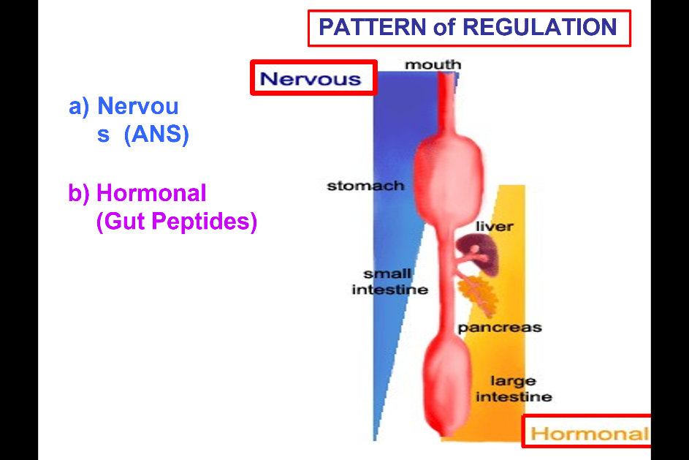
Regulation, Generation and secretion of the GIT
- Mouth at top and the rectum at the bottom
- The regulation is by both nervous system (automimic nervous system) and hormone or gut peptide also regulate the secretions
- The role of these 2 depends on the part of GIT
- At the level of mouth, the secretion is completely under control of nervous system (no hormone effect)
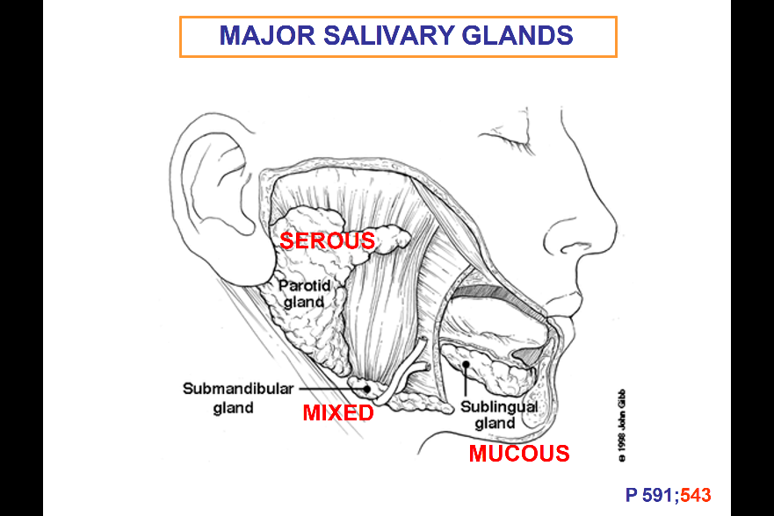
- At the level of end , most is hormonal very little is motor.
Salivary gland
- Periotic gland: at cheek, secret a serous fluid
- Sublingual gland (under the tongue ) : secret a lot of mucous to lubricate the bolus in the mouth
- Submandibular gland: it release mix of serous and mucous fluid
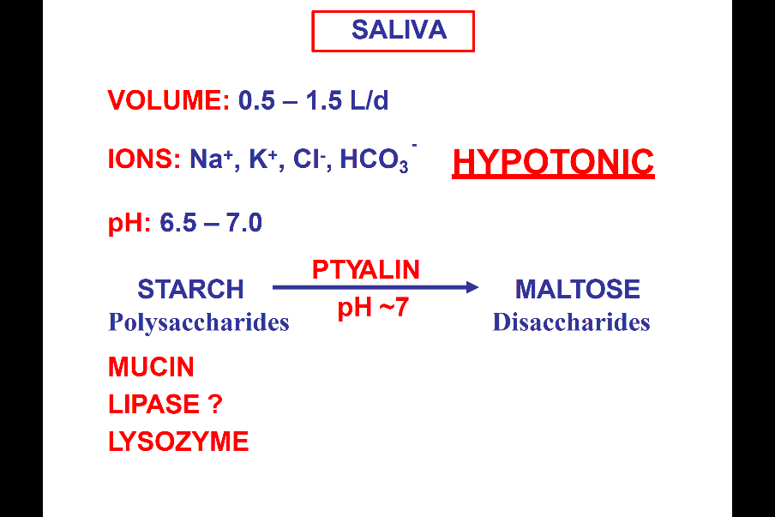
Everyday produce 0.5~1.5 L of saliva
- Ions: its hypotonic (of all the secretion in GIT, the rest is isotonic but this is hypotonic.)
- Neutral PH
- The main enzyme is ptyalin: break down polysaccharide, into disaccharide (the first step of processing and require the neutral PH)
- Lipase break down the fat (this is very small amount)
- Lysozyme, break down bacteria: if there is any bacteria break down the bacteria walls. (don’t play a role in food breaking , not focus)
- The main secretion In saliva are mucin, mucous, ptyalin
- The mucous to lubricate the bolus and protect the mucosa of the mouth.

The gland regulation in general
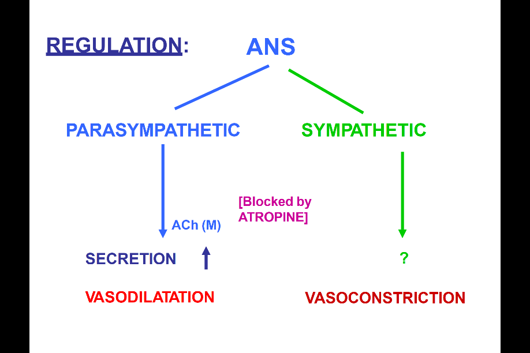
- Will have regulation from the autonomic nervous system (most important at the mouth as go down there will be more hormonal influence) but wherever ANS play a role this is how its gonna do it
- ANS input from the parasympathetic +sympathetic
- For most of the GIT, parasympathetic input release ACH at the level of ENs and this is block by atropine. The para is generally excitatory will increase the secretion: at the level of glandular cell in git will increase secretion. This is also an energy and blood flow depending process its also gonna serve to increase blood flow. Vasodilation along with the activation of parasympathetic, so the increase of the blood flow to the GIT to support the increase secretion
- Sympathetic: we see vasoconstriction , most part will decrease the secretion (only one example: salivary gland –actually have an increase in secretion and at the level of sublingual gland.
- For most of the GIT will deal with this scheme – PARA: INCREASE SECRETION, BLOOD FLOW (SYMPATHETIC THE OPPOSITE)
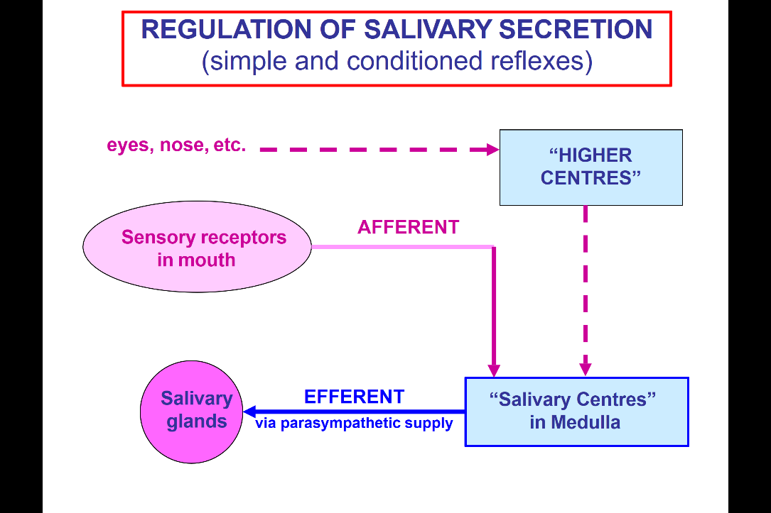
Sensory receptor in mouth –anything put in the mouth is going to lead to afferent activate the sensory neuron, sending out sensory information to salivary center of medulla and this will lead to efferent via parasympathetic innervation of salivary gland to increase salivation
- Any stimulus in mouth (ex: finger in mouth…) will lead to the afferent activation and increase ein the saliva
- Other type of sensation (see food , smell food, being prepared…) can all lead to the activation of the higher centers and that will send signals to this salivary center of medulla to activate the efferent.
- We can have both higher and physical sensation with in the mouth order processes lead to salivation.
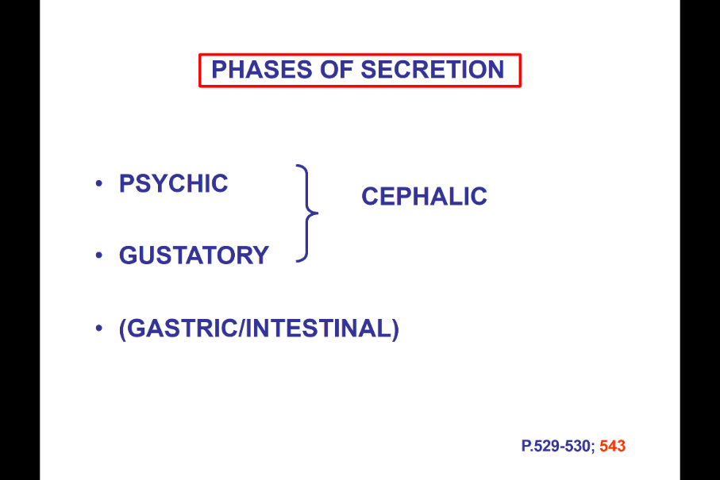
Psychic – condition reflex (see food , small food..) lead to salivation
Happen in mouth: the gustatory phase: the activation of taste receptor will produce secretion
Gastric/intestinal phase: when something is too warm or too cold, also lead to salivation
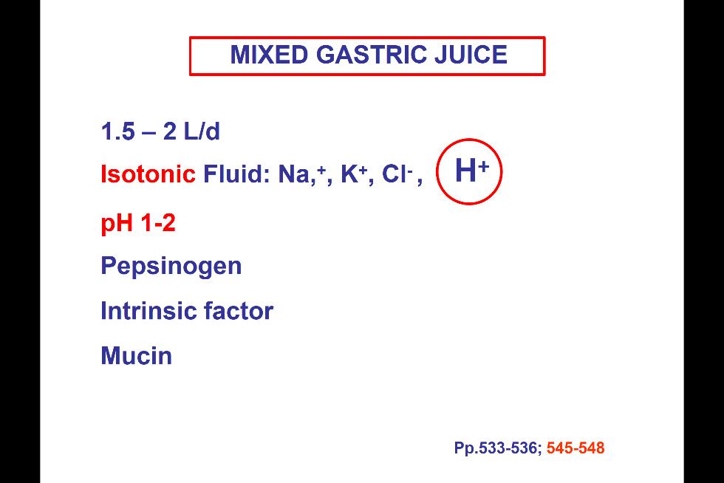
- But mostly is the gustatory and the salivation effect which is call the cephalic phase (because it comes from the head)

Secretion at the level of stomach
- Gastric juice. Also large amount all these will be reabsorb
- Isotonic: Hydrogen, large amount to give the low PH for break down
- Mix gastric juice is all the secretion that mix together, with a PH1~2 (because with all other secretion not only acid)
- enzyme release : pepsinogen, enzyme that will be break down to pepsin
- Intrinsic factor: for the absorption of B12, (absence will be pernicious anemia) Intrinsic factor is secreted by stomach, and B12 will be absorb at the level of SI)
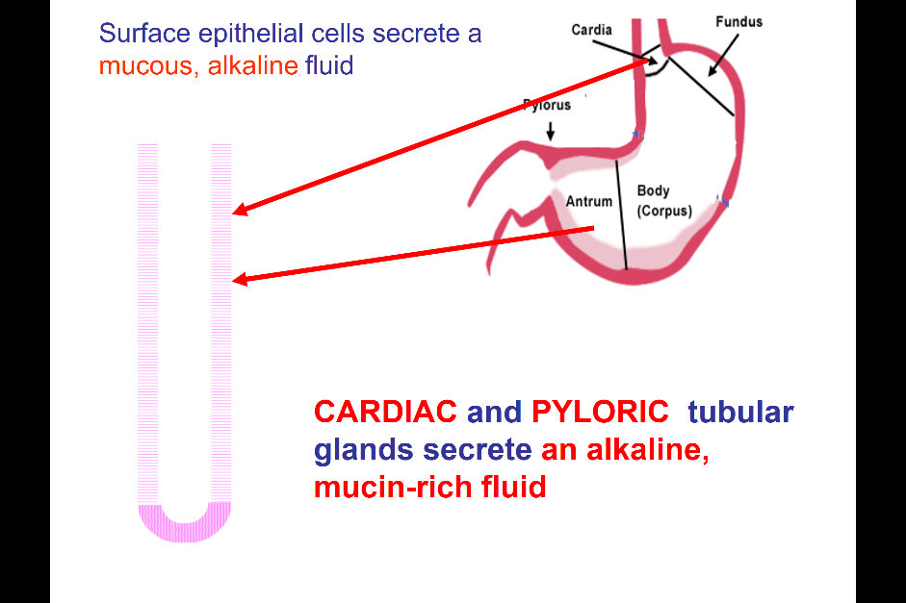
- Musin: mucous to protect the mucosa from the stomach
The mucous fluid is to protect the stomach, this happen in tubular gland.
The surface area of lumen (GIT lumen) is larger than serosa to have all the secretion and absorptive function take place, need more surface area (tubular is an example)
- The tubular gland mostly present in the antrum and cardia of the stomach (near the pyloric part and he cardia)
- Responsible for secreting alkaline, musin rich: secret quite abit to have 1~2mm Layer thick of mucous. That’s due to the secretion of the tubular gland at the epithelial cell (the thick layer will protect the stomach wall )
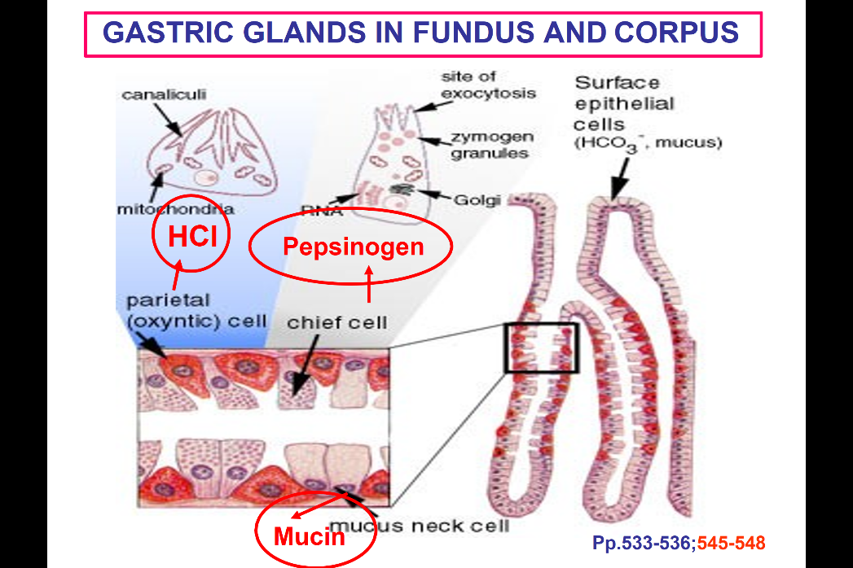
- Other things like acid , enzyme and intrinsic factor will be release at different part of stomach, at the fundus/body of the stomach is where most of these component will be release

Invagination in the wall if the stomach (lumen, and continuous)
- The surface epithelial cells will release the bicarbonate alkaline rich mucous type solution
- Other cells in the gastric gland of fundus and corpus will release other factors, we talk about different type of cells
- Parietal cell: secrete the HCL- acid, cell has the invagination(canaliculus) that will be in contact with lumen of GIT, to increase the surface are more at the level of parietal cell
- Chief cell: pepsinogen which is the precursor of pepsin
- Mucus neck cell: release the mucin
- The three different type of cell mix at the level of fundus and corpus
- These cells have a high amount of mitochondria (energetically active cell)
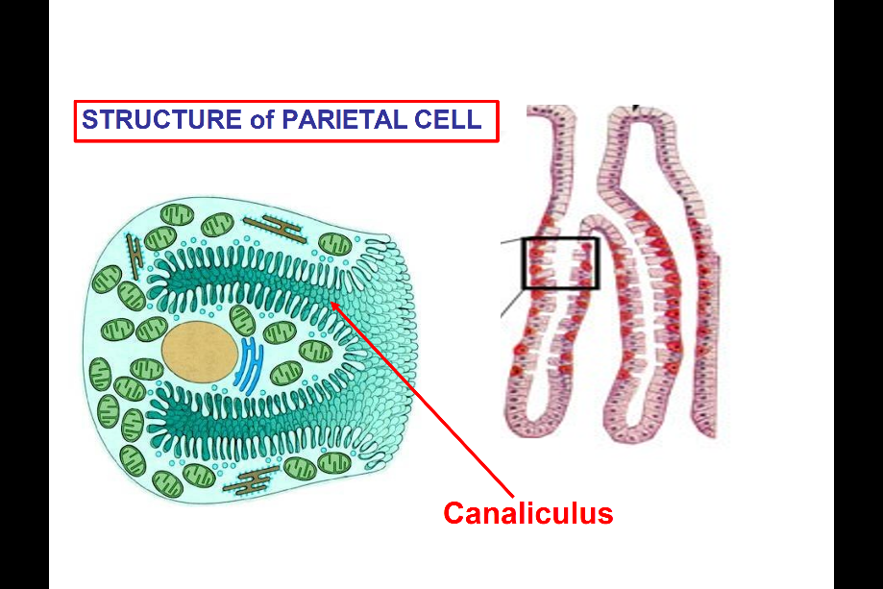

Each one of these canaliculi, the little wholes is connected to the lumen of the GIT , the acid will be secreted through the canaliculi to reach the lumen.
A lot of mitochondria to provide energy

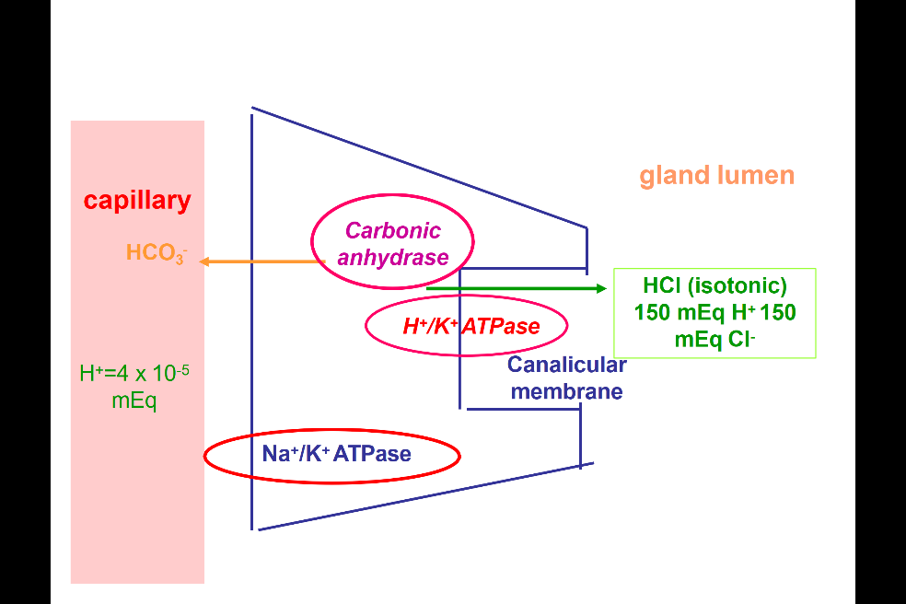
Why is this energy dependent process?
- Schematic of parietal cell
- Canalicular membrane in contact to gland lumen( stomach)
- The cell release the acid to lumen
- Blood (capillary underneath the cell layer) supply to GIT at the basal side of the cell
- Isotonic HCL is released release 150mEq of hydrogen (very acidic). Its also isotonic so secret 150 Cl-
- Within the blood stream, there are only 4*10^-5 mEq of Hydrogen circulating.
- To increase the huge amount of HCL, parietal cell must: move the hydrogen into the cell and concentrated, release to the stomach
- For every hydrogen let out will put a bicarbonate back to the blood stream
- Depends on 1) carbonic anhydrase (most important): to move the hydrogen
2) the hydrogen potassium ATPase will be important to move Hydrogen out to the lumen 3) Na+/K+ at the base that will move the important for moving the process through the cell
- Require a lot of ATP (mitochondria) to concentrate H= and moveout at high concentration of H+
- For ppl who have too much acid in stomach, can’t target carbonate anhydrase to decrease the acid. Because carbonate anhydrase is in all the cell. Can’t target Na+/K+ ATPase, because its also widely express in the body
- The H+/K+ ATPase is quite unique, this is the target. PPl take proton pump inhibiters, this is specifically targeted.
- Isotonic , low H+ amount in blood stream
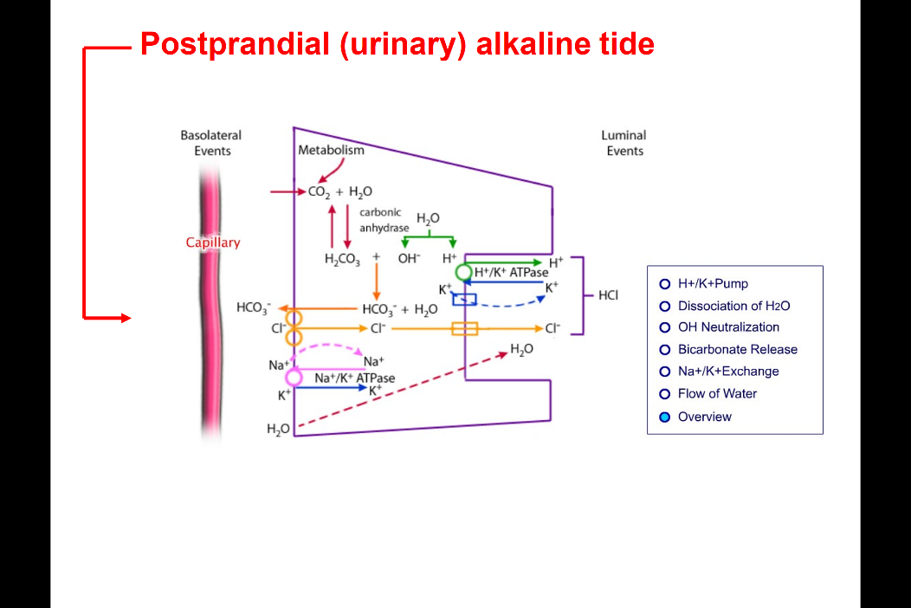
Detailed to be learn (not responsible)
- For interest
- point out that :bicarbonate is release to the blood, if eat a protein rich meal (have a lot of acid to release to break down) – have postprandial alkaline tide: urine analysis will see a very alkaline urine.( ppl use as blood test to see how much acid the stomach is producing)

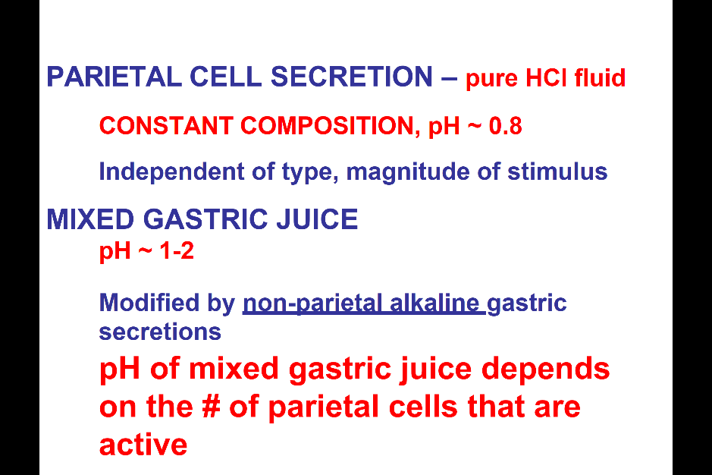
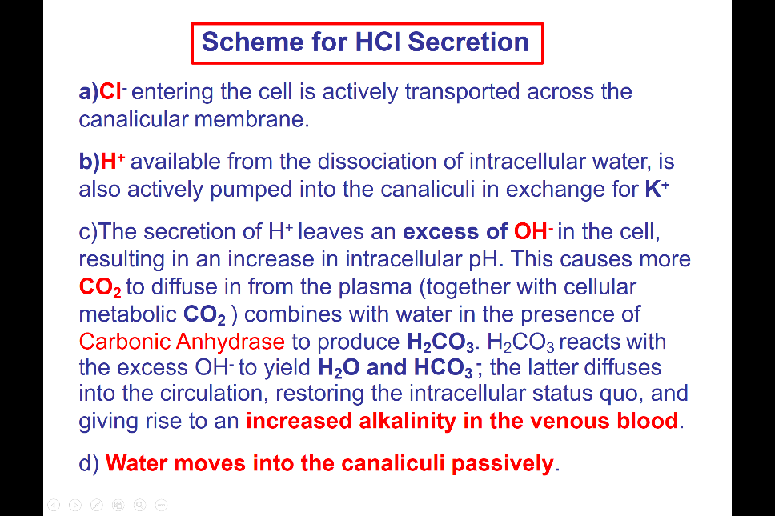
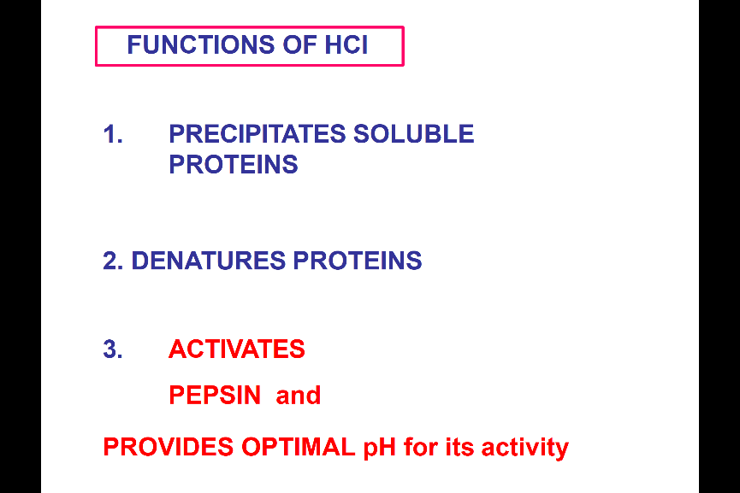
The mixed gastric juice is 1~2 because of the mixing with all the other secretion. But the parietal secretion is at PH:0.8. Always secreting HCL with this Ph.

